PRODUCTS
The Viper MKII Series enable’s wire ropes to be safely, quickly and effectively lubricated and has the potential to extend their life significantly. The Viper WRL MKII eliminates manual greasing, reduces downtime and improves equipment availability. It is a safer way to lubricate wire ropes, reduces lubricant usage, has less leakage and reduces mess.
See below the range of product Viper offers.

VIPE WIRE ROPE LUBRICATOR
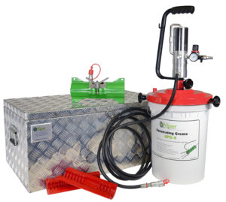

VIPER MINI MKII

Suitable for wire ropes – 6MM to 36MM

The Viper Mini MK II provides a light weight, easy to use option for smaller or hard to access wire ropes.
Read More
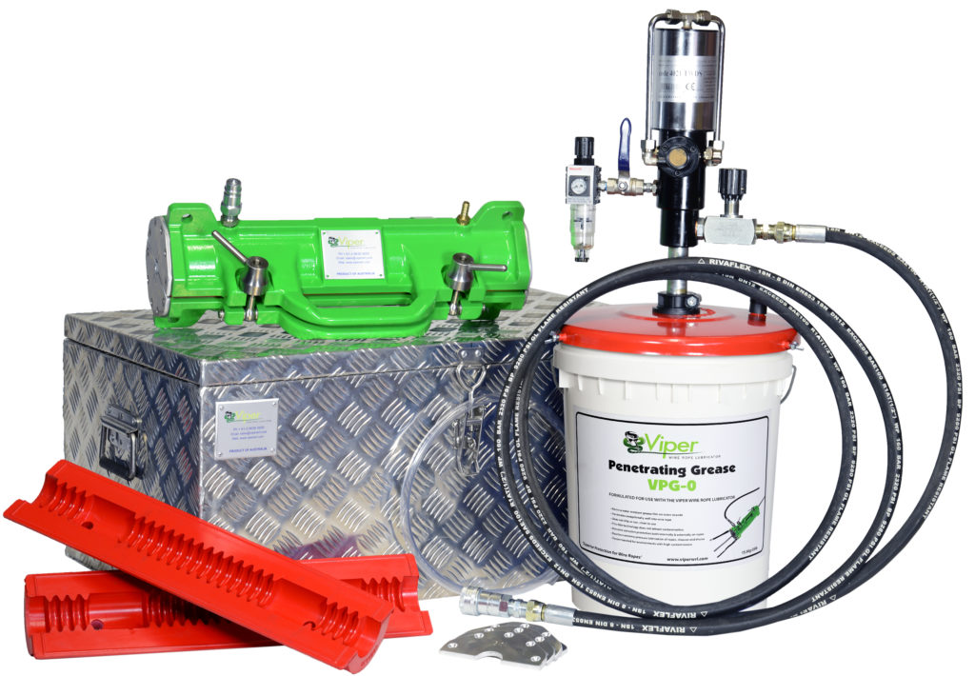

VIPER MID MKII

Suitable for wire ropes – 6mm to 67mm
Fast and effective lubrication of wire ropes with a diameter between 6mm to 67mm.
Read More
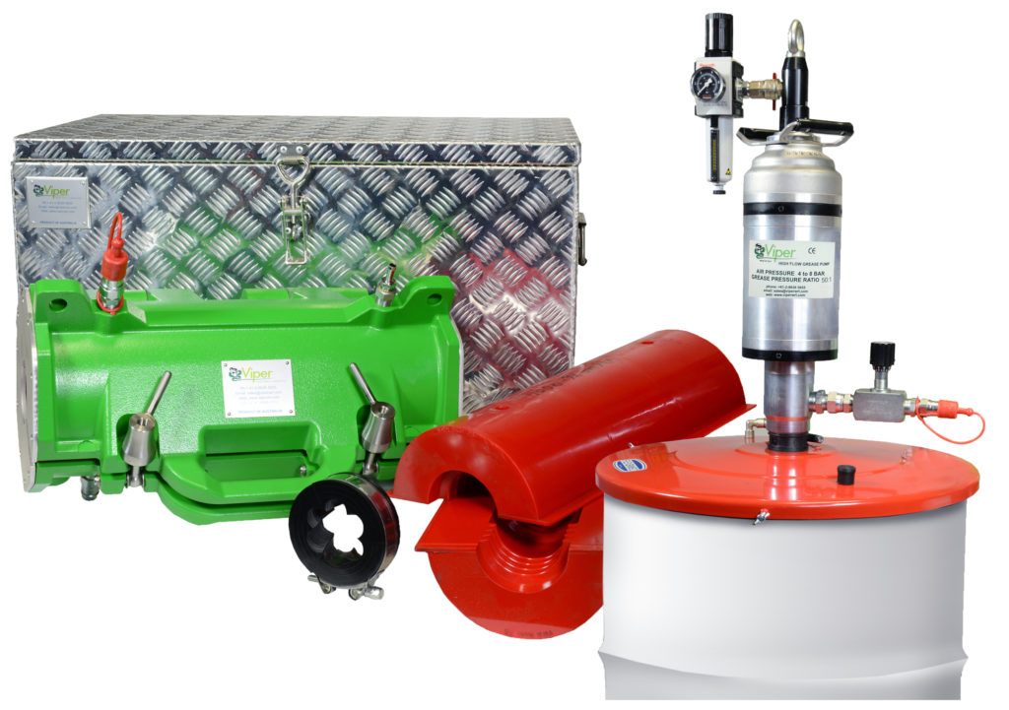

VIPER MAXI MKII

Suitable for wire ropes – 50mm to 165mm
Recommended for use with ROV Cables, Vessel Crane Ropes, Underwater Offshore Wire Ropes and Drag Lines.
Read More

VIPER WIRE ROPE CLEANERS
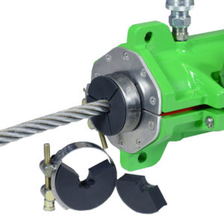

VRC ROPE CLEANER
Viper Rope Cleaners enable the removal of contamination or built up old lubricant from the wire rope prior to lubrication, improving the effectiveness of the lubrication process via the Viper WRL.
Read More
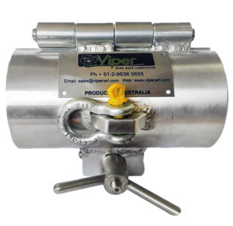

VMRCS
To achieve optimum performance of wire rope assets it is critical that old lubricant & contamination is removed from the outer strands and valleys of the rope, prior to inspections and before re-lubrication is completed.
Viper WRL has revolutionised the process of cleaning ropes by combining CAD based design with manufacturing techniques and composite materials to deliver the Viper Manual Rope Cleaner Solution Kit.
Read More

ACCESSORIES
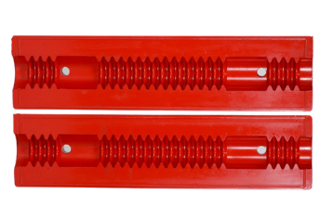

SEALS
The Viper seal design and carefully tested polyurethane-blend material allows the lubricant to effectively penetrate into the core of wire ropes, where corrosion is most critical and often undetected. Viper MKII Seals have been field-tested and proved to be extremely durable and wear resistant, while retaining their flexibility to achieve best “grease massaging” effects into wire rope core. The Viper MKII Seals can last up to 12,000 – 15,000m of rope lubrication
Read More
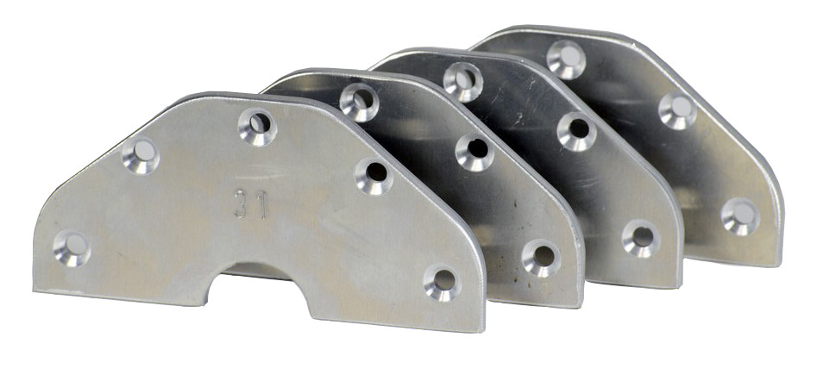

SCRAPERS
The Viper WRL Scraper plates enable safe entry of broken wires into the seal ensuring the rope and seal is not damaged.
Viper recommend that wire ropes be physically measured prior to ordering seals and scrapers as ropes in service may vary in size. Scrapers are supplied slightly larger than the actual wire rope size to allow for rope flexing.
Read More

